**Computer networks laboratory week 10**

**Name: Pranav R. Hegde SRN: PES1UG19CS343 Section: F1**

**IPv6 static routing and addressing**

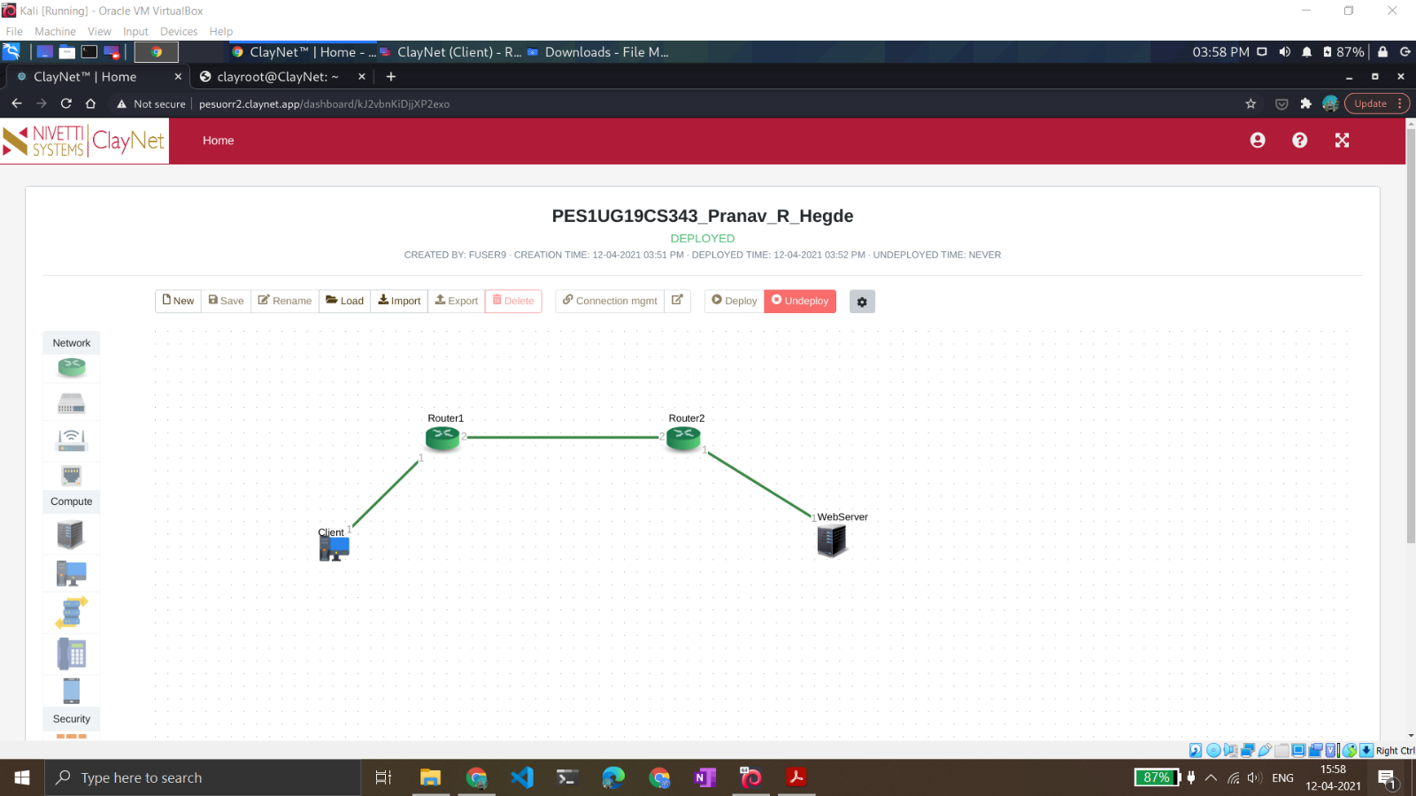

The deployed topology

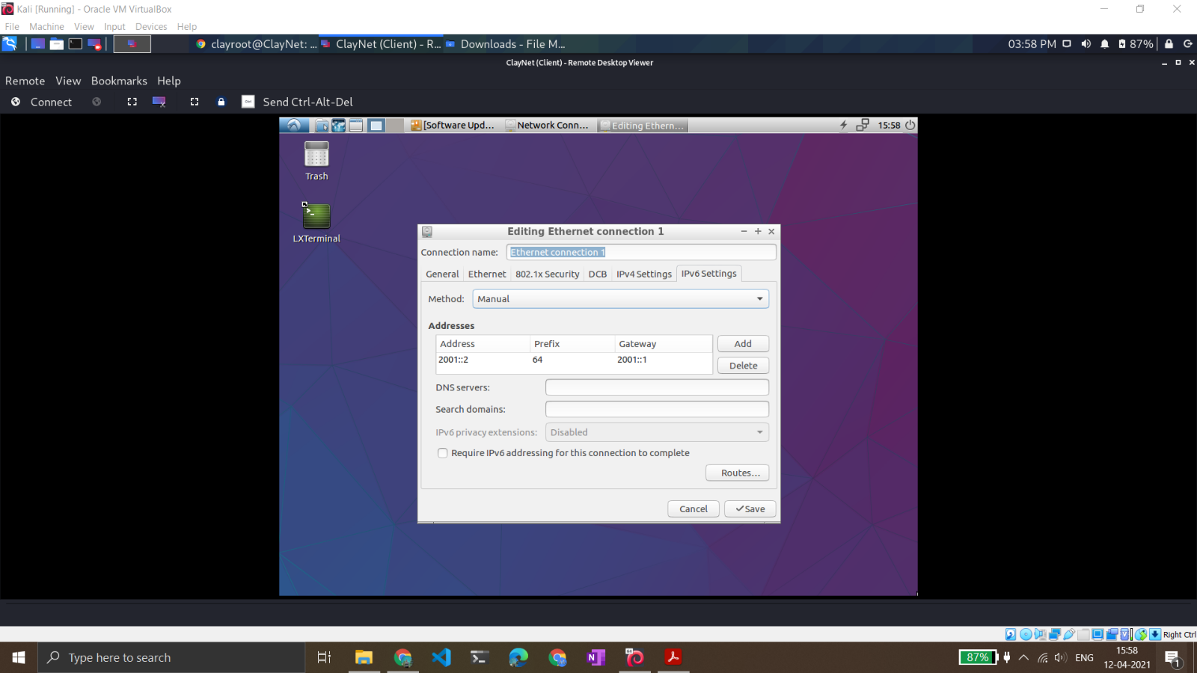

Setting the client machine IP address.

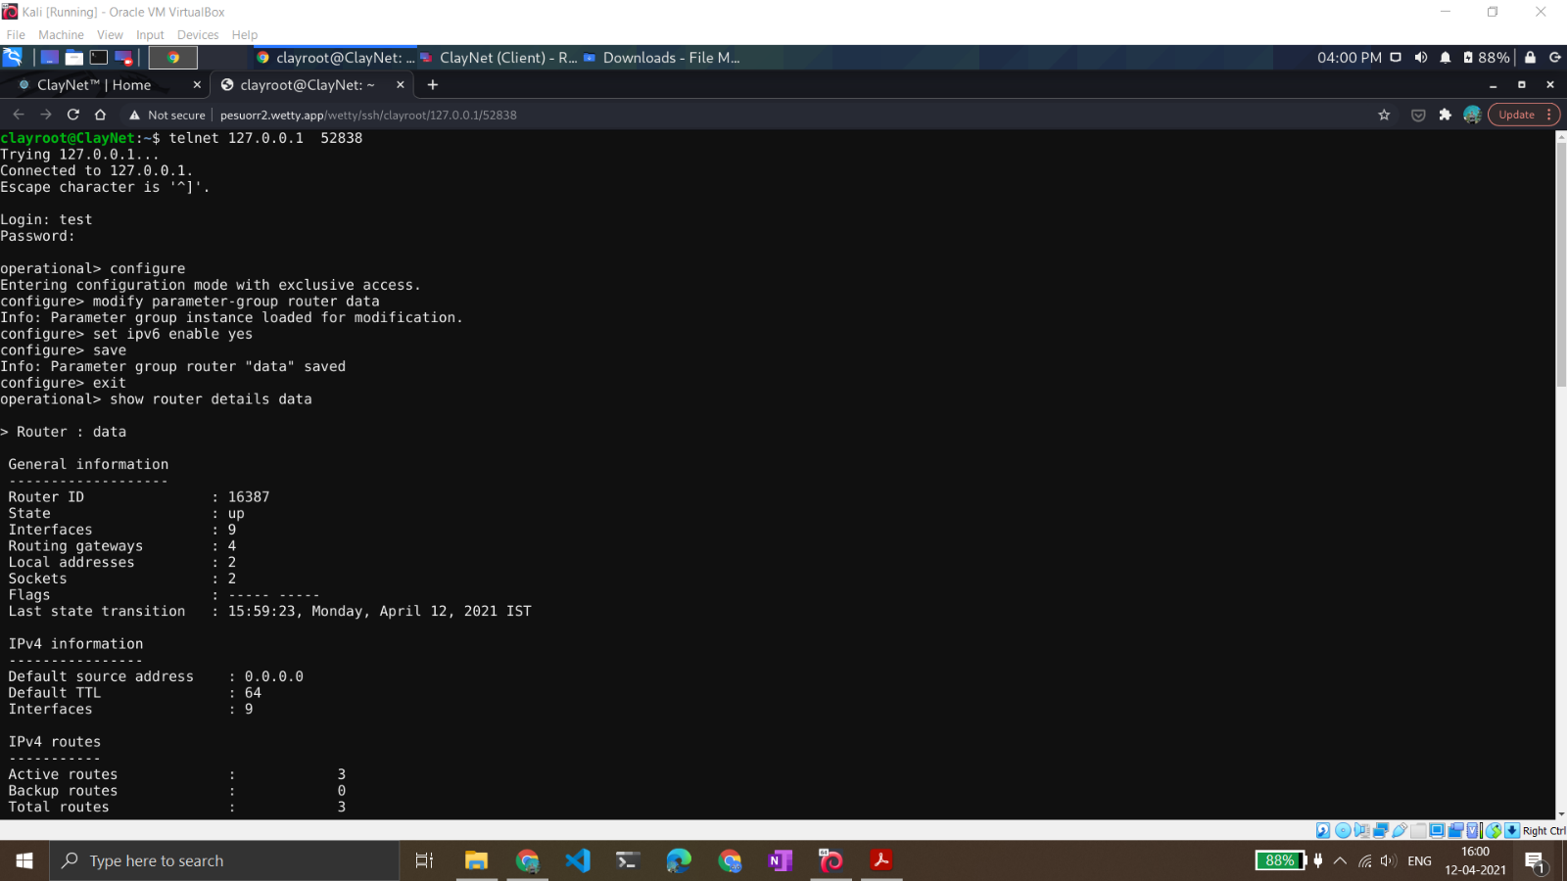

Displaying router1 details data.

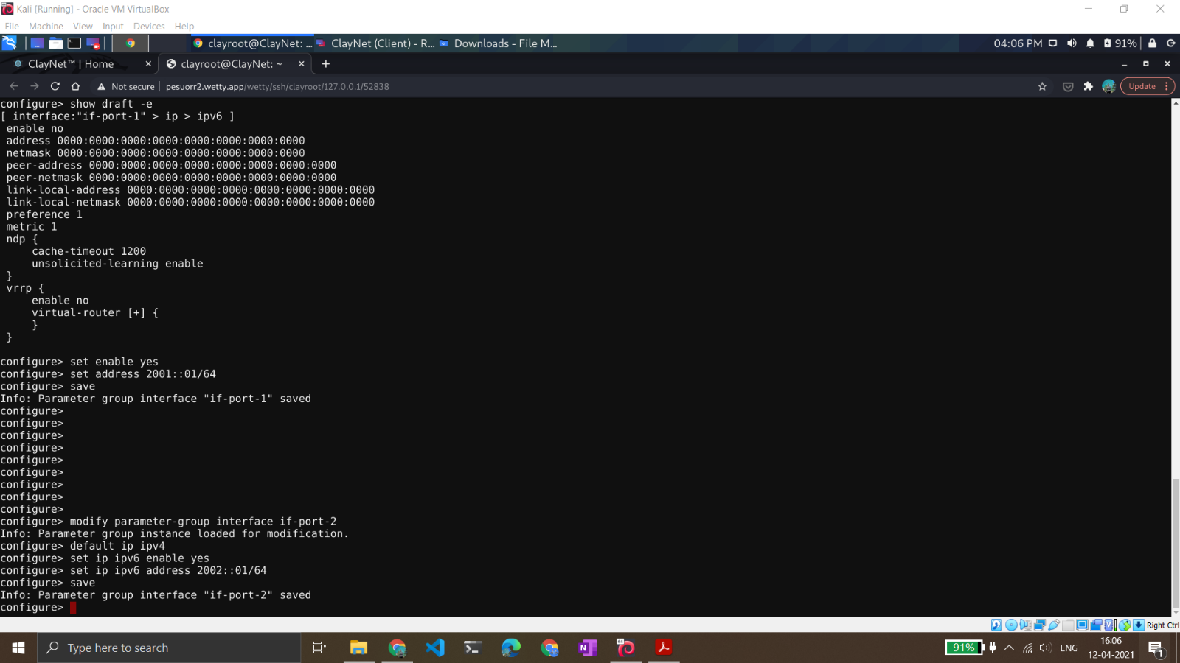

Setting the router1 IP address.

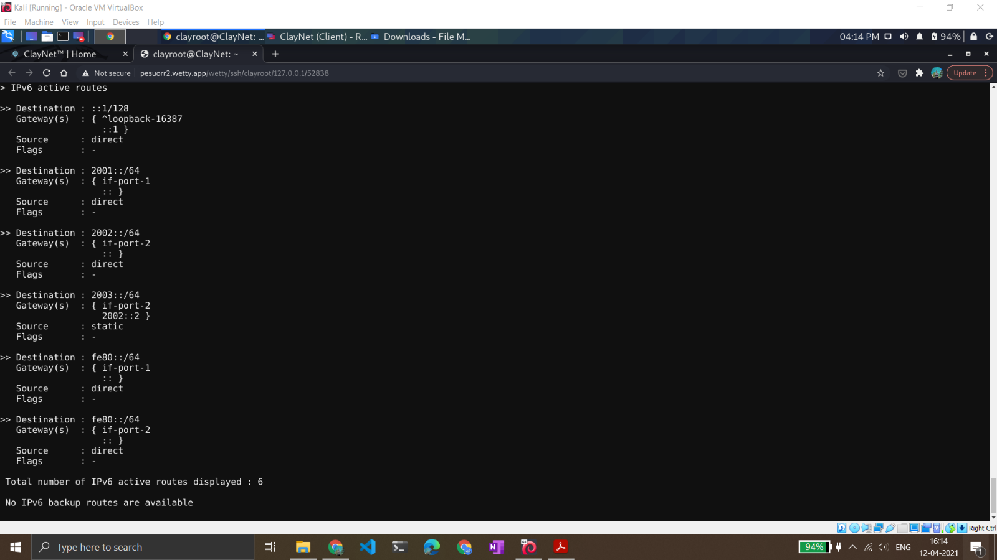

Displaying the available interfaces after adding two new interfaces for both the routes.

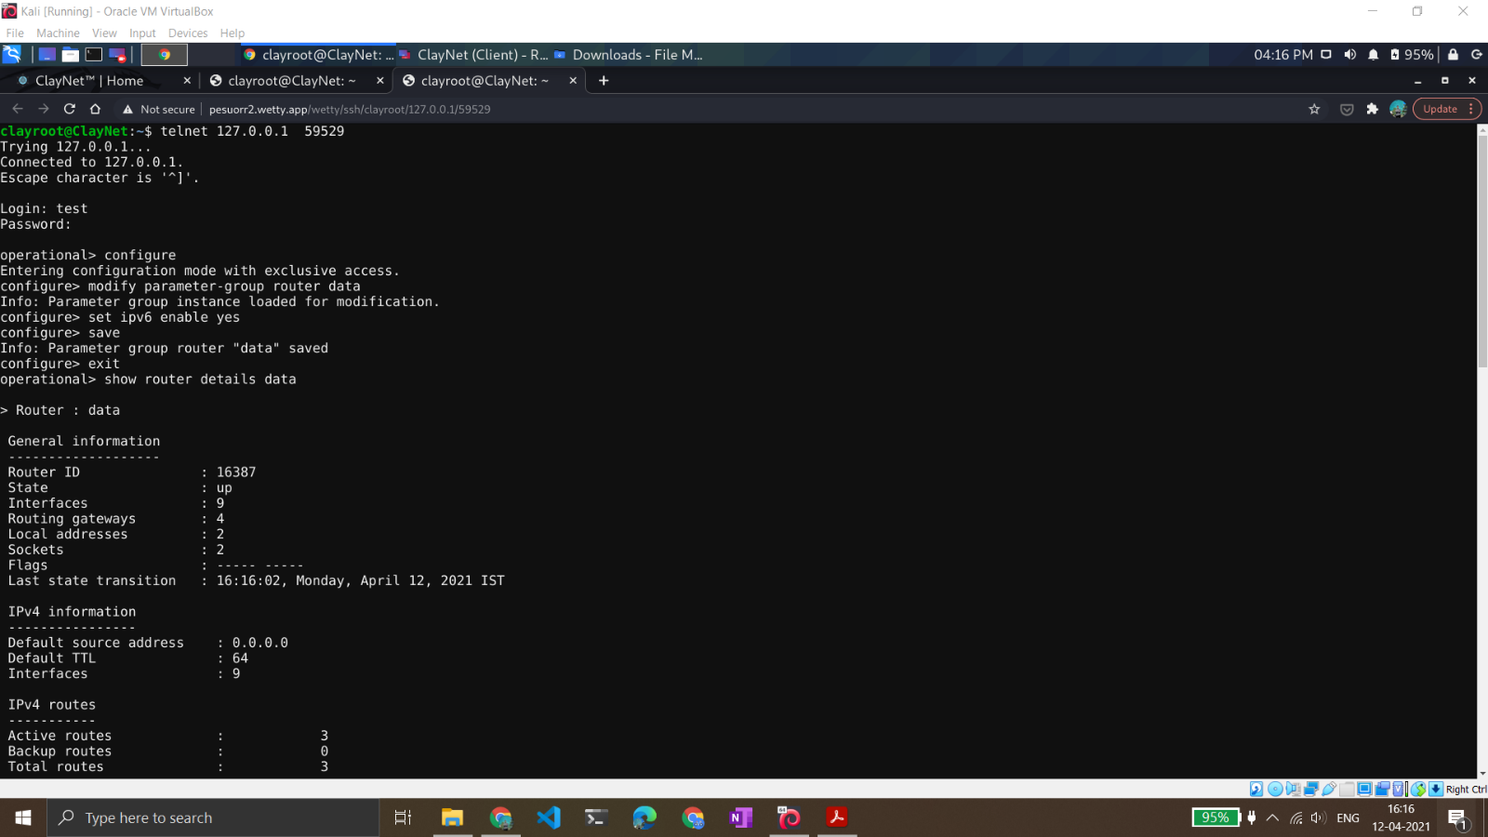

Displaying the router2 details data.

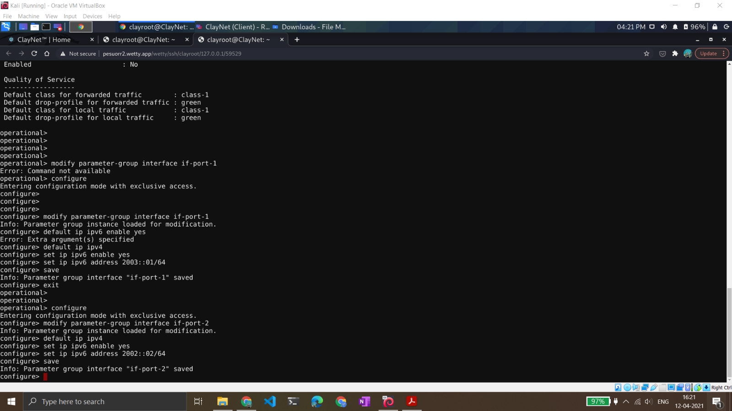

Setting the IP addresses and gateway for router2.

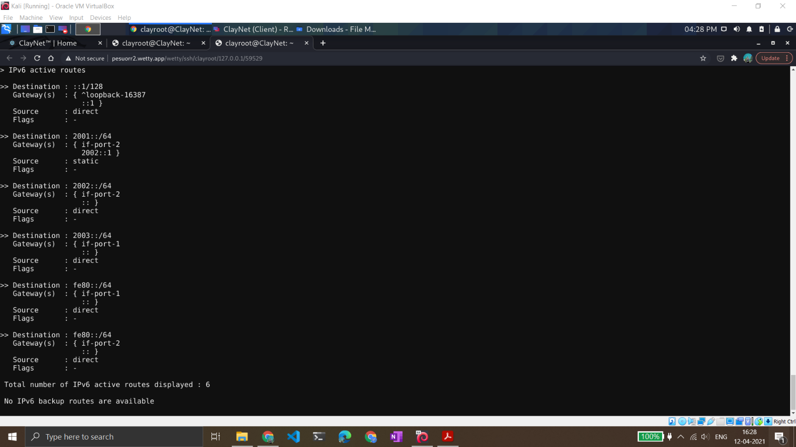

Displaying the available interfaces after adding two interfaces.

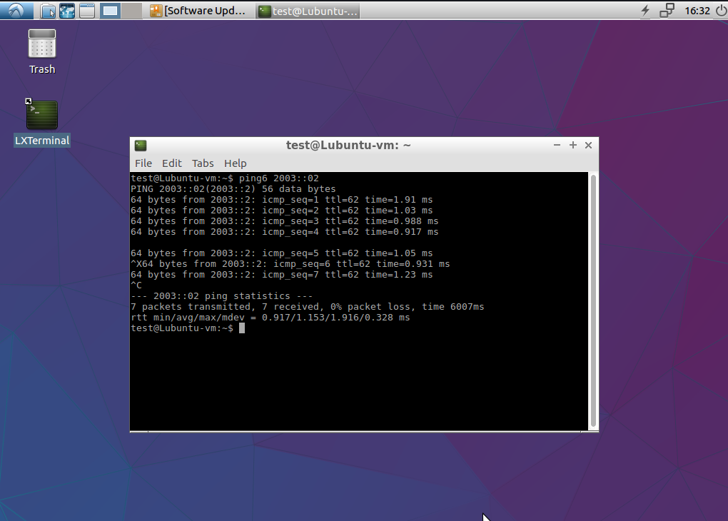

Pinging webserver from the client machine. Observe the TTL to be 62 due to the presence of two routers in between.

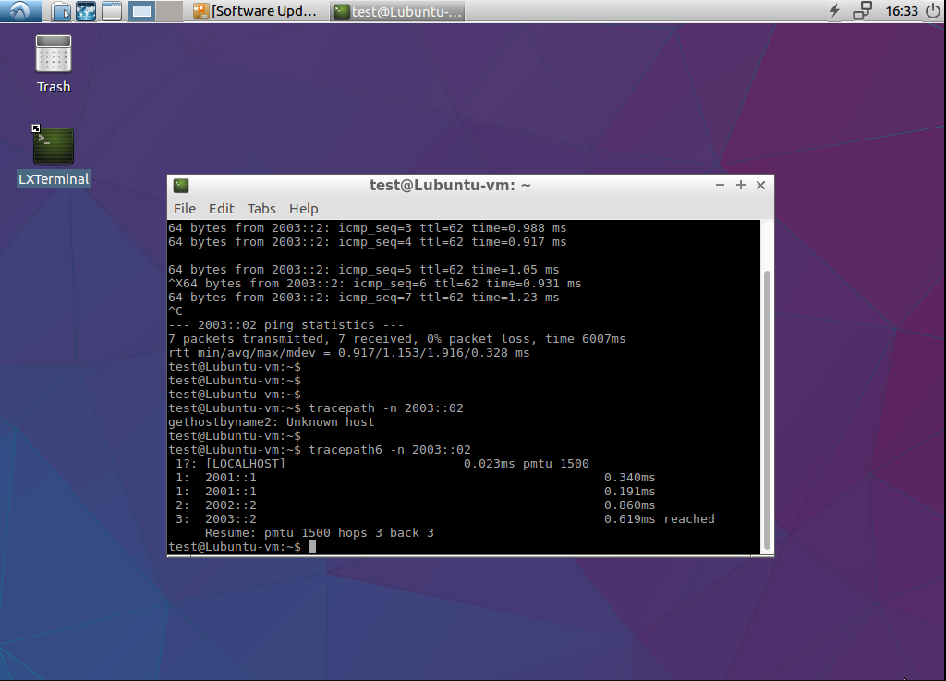

Executing the tracepath6 command in order to checking the traffic flow between Alice(client) and Bob (Webserver).

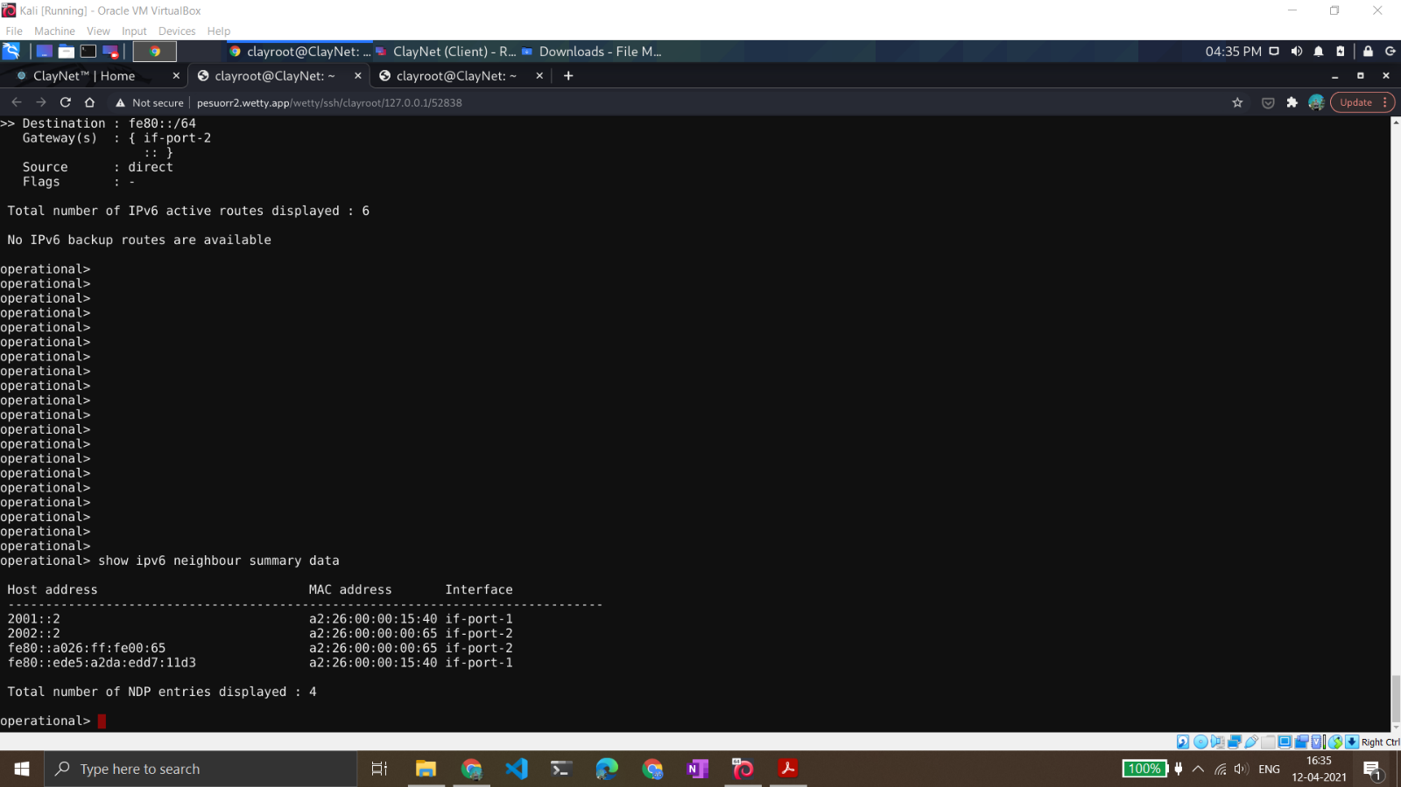

Neighbour summary data on router1.

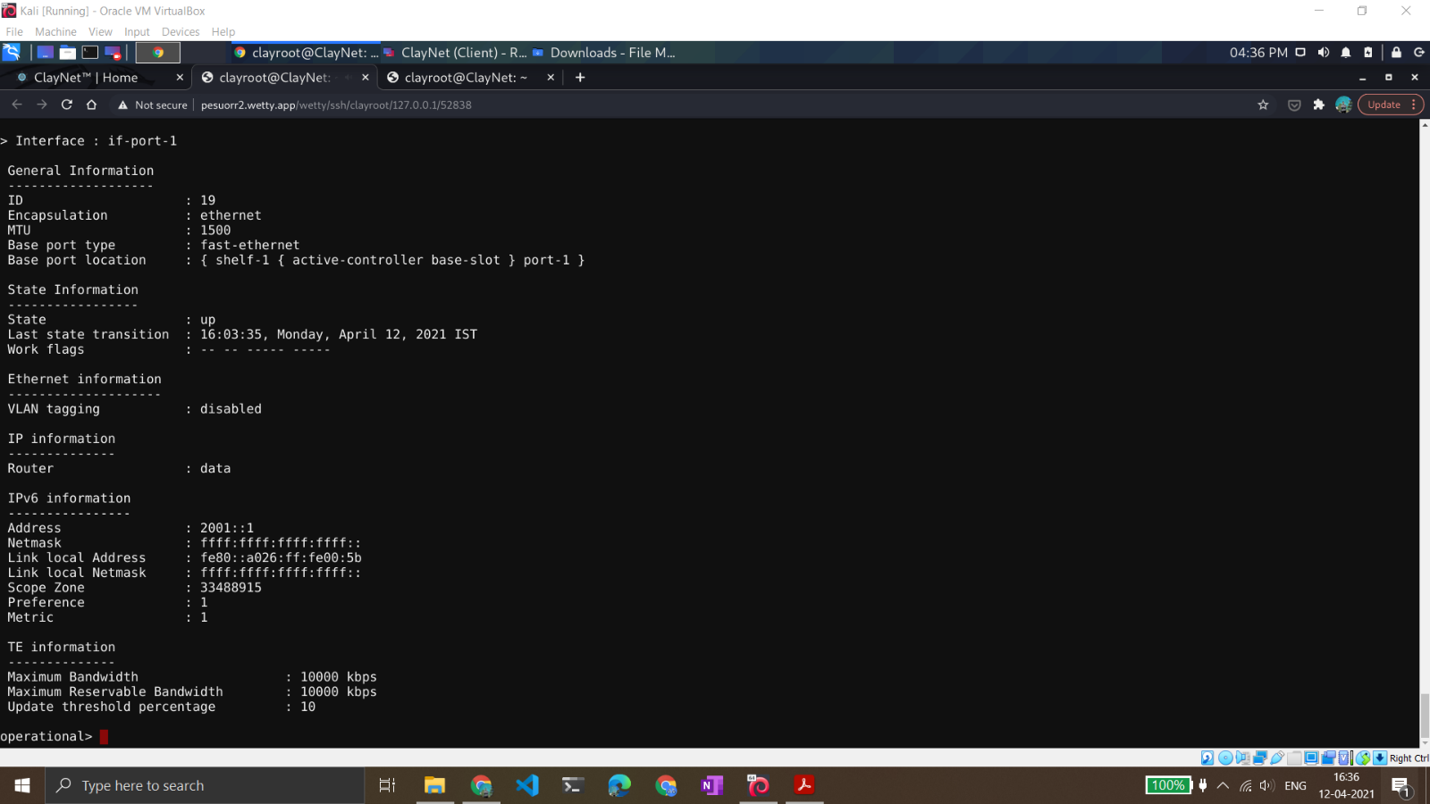

Verify auto-configured Link Local Address on IPv6 interfaces.

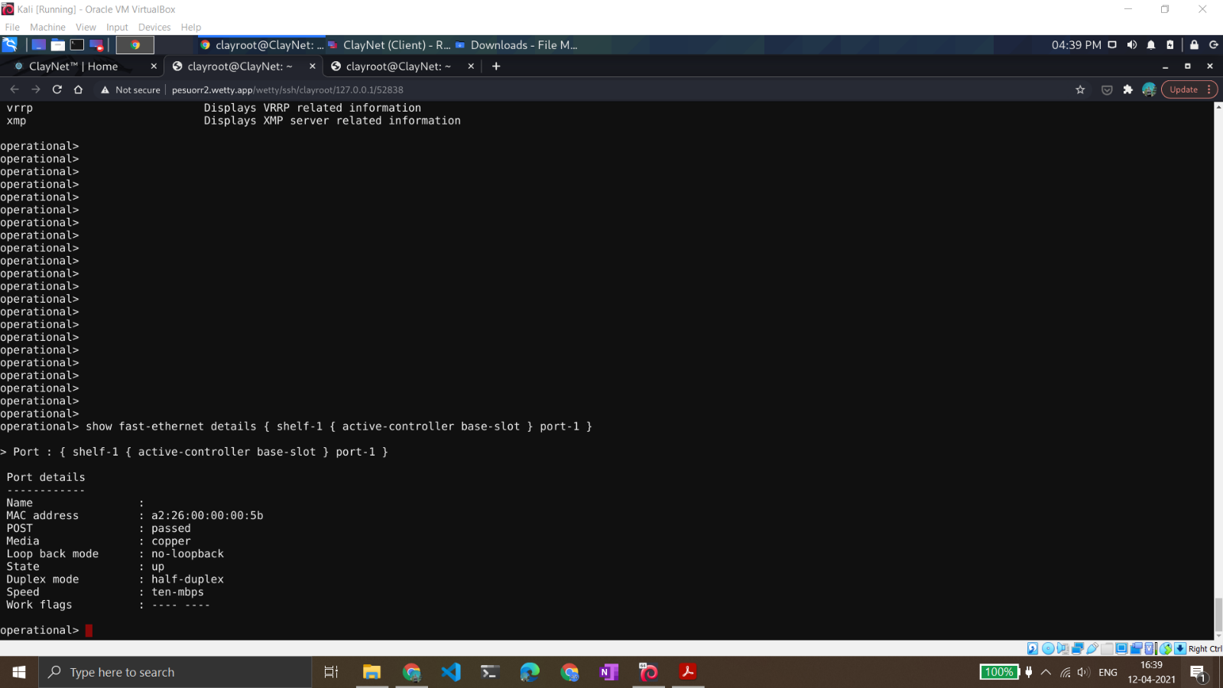

Displaying fast ethernet details portraying the connection details between the router1 and router2.

